step1:Create new project-> Asp.net (.net framework)->choose MVC project

Step2: In Solution Explorer-> Go to Model Folder-> right click on Model Folder-> add ->new item->add class1.cs-> give name Student.cs->click on add Button
You will see in Model folder Student.cs file is added
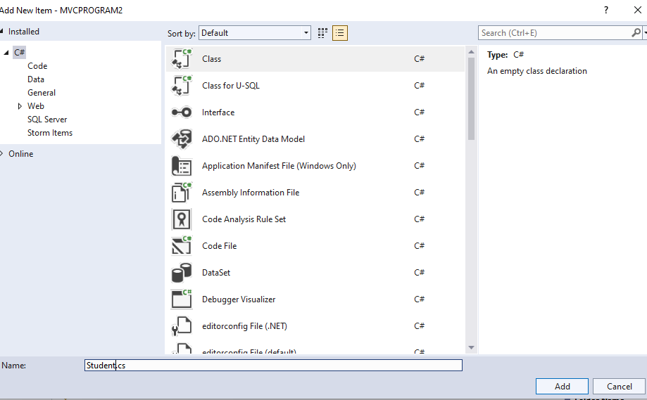
Step3:Open the Student .cs
Add the below code inside the class
public int StudentID
{
get;
set;
}
public String StudentName
{
get;
set;
}

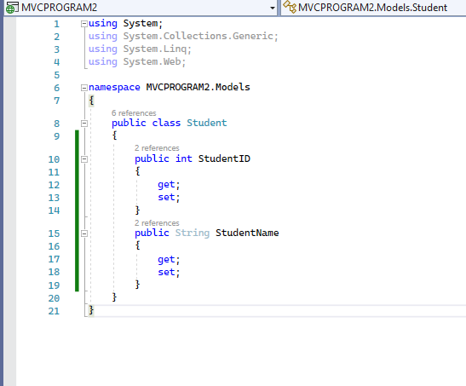
Step 4:In Solution Explorer go to-> Controllers Folders->then open the HomeControllers.cs file
Inside the HomeController class add the ActionResult for ShowStudent()

// GET: Home
public ActionResult Index()
{
return View();
}
[HttpPost]
public ActionResult ShowStudent()
{
Student std = new Student();
std.StudentID = int.Parse(Request.Form["sid"].ToString());
std.StudentName = Request.Form["sname"].ToString();
return View(std);
}
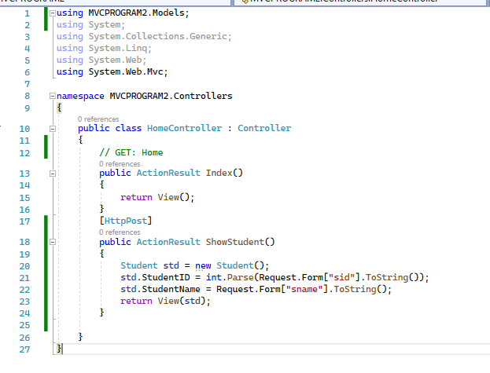
Step 5:open the HomeContoller.cs->Riight click on ShowStudent()->Add View->choose MVC5 View->click on add button

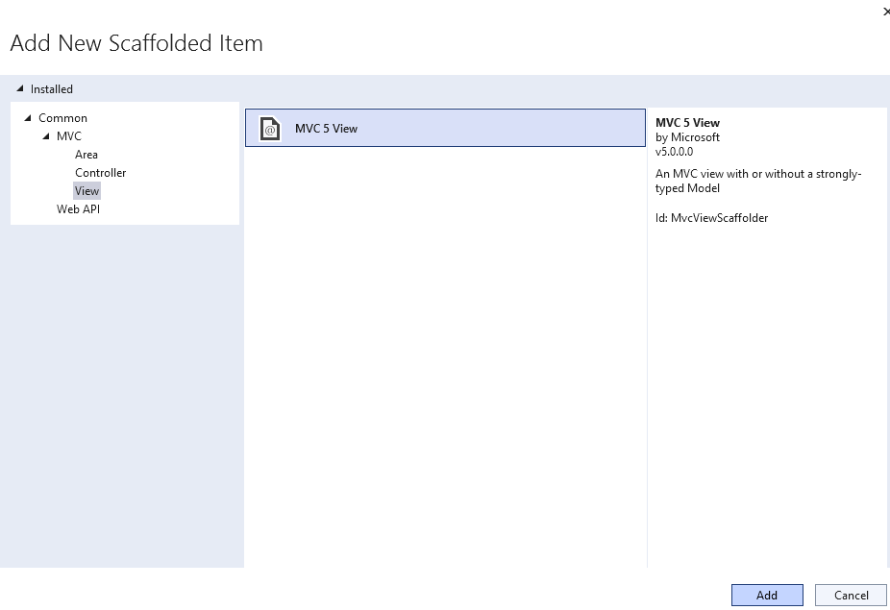

In Add view Window->Choose -Template value as Empty and Model Class as Student-> click on add button
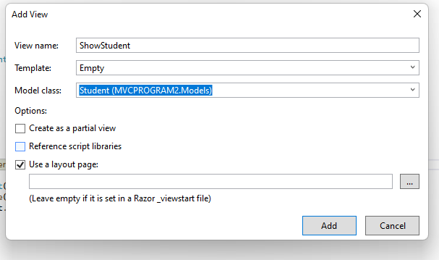
Step 6:in Solution explorer-> Views->Home->ShowStudent.cshtml is added
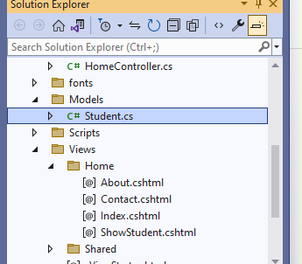
Step 7:Go to Views-> Home->open the Index.cshtml
@model MVCPROGRAM2.Models.Student
@{
ViewBag.Title = "Index";
}

<h2>Index</h2>
@using (Html.BeginForm("ShowStudent", "Home",FormMethod.Post))
{
<div>Enter ID: @Html.TextBox("sid")</div>

<div>Enter Name: @Html.TextBox("sname")</div>
<input type="submit" value="Display" />
}
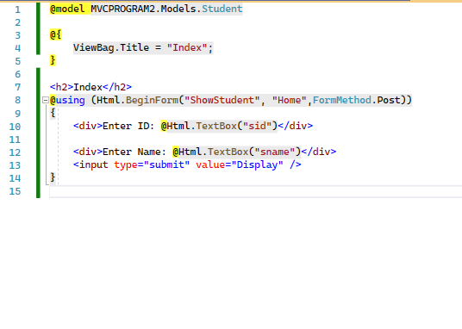
Step 8:Go to Views-> Home->open the ShowStudent.cshtml
@model MVCPROGRAM2.Models.Student

@{
ViewBag.Title = "ShowStudent";
}

<h2>ShowStudent</h2>

<div>Student ID: @Model.StudentID</div>
<div>
Student Name: @Html.Label("stname",Model.StudentName)
</div>
Step 9 : execute the Index.cshtml file

